21 January 2005

To: Paul Philp, DOE Project Manager, Run IIb D-Zero Detector Project

From: Vivian O’Dell, Project Manager, Run IIb D-Zero Detector Project

Subject: Run IIb D-Zero Detector Project Report for November 2004

Attached is the monthly report summarizing the November 2004 activities and progress for the Fermilab RunIIb D-Zero Detector Project.

electronic cc:
M. Abolins
J. Appel
E. Arroyo
L. Bagby
E. Barberis
A. Bean
J. Blazey
A. Bross
W. Cooper
M. Demarteau
D. Edmunds
T. Erickson
H. Evans
S. Fuess
G. Ginther
U. Heintz
M. Hildreth
R. Hirosky
D. Hoffer
K. Johns
M. Johnson
- Knapp
R. Lipton
J. Livengood
P. Lukens
R. McCarthy
H. Montgomery
M. Narain
A. Nomerotski
V. O’Dell
P. Padley
R. Partridge
V. Pavlicek
TJ Sarlina
R. Sidwell
P. Slattery
K. Stanfield
RP Smith
J. Strait
L. Stutte
E. Temple
C. Trimby
V. White
M. Witherell
D. Wood
T. Wyatt
C. Yoshikawa
Fermi National Accelerator Laboratory
Run IIb D-Zero Detector Project
Fermilab Experiment Number E925

Progress Report No. 24
November 2004

- Project Description

The Tevatron Collider at Fermilab offers a unique capability to elucidate many of the major issues currently facing particle physics. Its high center-of-mass energy and recently upgraded luminosity offer us the capability of shedding light on the Higgs mechanism - which has the potential of offering insight into the origin of mass - and pushing the boundaries of searches for supersymmetry and other new phenomena beyond the Standard Model. It also makes accessible improved precision measurements of the W boson and top quark properties that, by further constraining the Standard Model, provide increasingly stringent tests of its precepts. The Tevatron offers the most cogent experimental probes of Standard Model physics, and beyond, during the coming 5+ years.

The Run IIb D-Zero Detector Project has been designed to allow the D-Zero Experiment to continue operating in the high intensity Tevatron environment for the remainder of the coming decade. The integrated exposure of the D-Zero Detector to colliding beam will result in radiation damage to the silicon detector that will compromise its efficiency. Adequate b-tagging is an essential ingredient of the Run II physics program. In order to maintain adequate b-tagging, D-Zero is adding an inner layer detector of radiation-hard silicon to enhance tracking efficiency as the Run IIa detector ages. In addition, the trigger system must be upgraded in order to provide sufficient rejection and to limit the dead time at the higher instantaneous rates that will be delivered by the Tevatron as the run progresses. The Run IIb D-Zero Detector Project provides for the additional D-Zero Layer 0 silicon detector and the upgrade of the D-Zero trigger, DAQ, and online systems in order to enable the continued efficient running of the experiment, and the acquisition of forefront physics data, for the foreseeable lifetime of the Tevatron collider program.

- Overview of Project Status

Strip testing at Stony Brook continued. The four Layer 0 readout chains, installed into DZero during the shutdown, were successfully read out. More hybrids were produced and some full chain testing done using production twisted pair cables, production HV/LV cables and prototype digital jumper cables, with the aim to verify the performance of all the components and to sign off on the new jumper cables. Electrical tests with several prototype modules being read out simultaneously are underway. The Layer 0 carbon fiber support structure, shipped from University of Washington last month, has been visually inspected and measured. Mechanically it is within specifications. The only flaw found on the structure is a local loss of gold plating at one hybrid mesh grounding circuit. The final LV Power Supply system for the Layer 0 was completed and partial operational readiness clearance was obtained. Some H-disk cable reorganization was done during the shutdown in order to make installation of the new Layer 0 adapter cards easier.
For the trigger upgrade, fabrication and assembly of ten ADF v2 boards started in November, and the boards are expected back in mid-December. The production TAB/GAB boards are also being assembled and are expected back at the end of December. Final measurements of the prototype BLS-to-ADF transition system were made and production of the final BLS-to-ADF system is expected to begin in January. The production Cal Track-Match Universal Flavor Boards were submitted for fabrication and the rack infrastructure was reconfigured during the shutdown. For the L1 CTT, more testing of the DFEM/DFEA board continued in November. Some bugs were found and fixed in the firmware. One board was installed in the DZero detector and read out through the normal readout chain. The board is working well and tests are continuing. A new SBC for the Level 2 Beta upgrade has been bought and, so far, tests show that it is easier to use than the Concurrent SBC’s. In addition to hardware work, algorithm development is moving along – we will need new algorithms with good rejection at L2 once the new L1 cal trigger goes in. The decision about the STT upgrade was postponed until December. The trigger simulation group has been very active. The optimal electron algorithm for the L1 Cal was agreed on by the simulation, physics and hardware people. The simulation software itself is progressing, with the idea of getting all the RunIIb trigger simulation software integrated in the DZero trigger simulation package trigsim. The AFE prototyping is going along – the new TriPt prototypes are fully functional, and it looks like no design changes are needed. The critical path for the project is now the AFE IIt prototype board.

The online system server system backbones were all successfully installed during the shutdown. The migration of Online operations to the Linux servers from the current Alpha servers was successfully completed. The DAQ rates were measured and are as expected. The control systems (Motorola PowerPC 8500 processors) have been successfully tested, and the full complement will be ordered for the summer shutdown.

- Project Milestone Summary (as of 30 November 2004)

The DOE baseline milestones are shown in Figure 1 as solid diamonds. These fixed milestones are defined in the modified DOE Project Execution Plan approved in December 2003. Shown as open diamonds on the same line, are the project’s projected dates for achieving the milestones. Actual dates of achieving milestones are shown as solid stars. The silicon, trigger and online milestones are shown separately with milestones sorted by current forecast date.

Table 1 shows the difference in the current forecast and last month’s forecast for achieving the DOE milestones. This table lists approved DOE milestone dates along with the project’s current (and previous month’s) forecast for achieving them. The list is sorted by DOE Milestone date. Milestones with forecast dates that have changed significantly in the last month are discussed in Section VIII of this report.

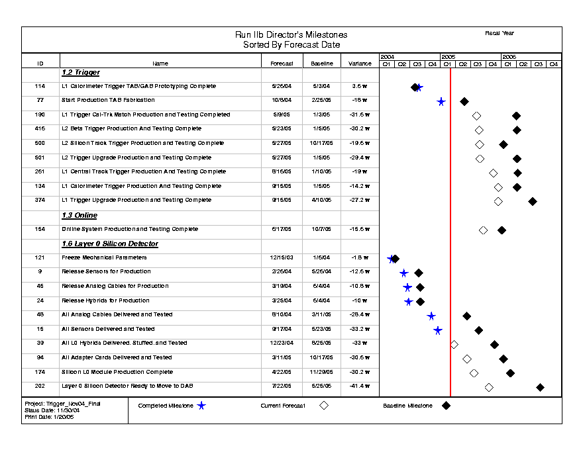
Figure 1: Run IIb D-Zero Detector Project DOE Level 2/Director’s Milestones. Closed (open) diamonds represent baseline (current forecast) dates. Closed stars represent completed milestones.

L2/Director's Milestones vs Current Forecast
(Sorted by L2/Director's Baseline Date)
Milestone Description | L2/Director's Baseline (11/04) | Last Month's Forecast (10/04) | This Month's Forecast (11/04) | L2/Director's Variance (work days) | Monthly Variance (work days) | Notes
WBS 1.2 Trigger
L1 Calorimeter Trigger TAB/GAB Prototyping Complete | 05/03/04 | 05/26/04 | 05/26/04 | 18 | 0 | Complete
Start Production TAB Fabrication | 02/25/05 | 10/08/04 | 10/08/04 | (90) | 0 | Complete
L2 Silicon Track Trigger Production and Testing Complete | 10/17/05 | 05/27/05 | 05/27/05 | (138) | 0
L1 Trigger Cal-Trk Match Production and Testing Completed | 01/03/06 | 05/31/05 | 05/09/05 | (158) | (15)
L1 Calorimeter Trigger Production And Testing Complete | 01/05/06 | 08/17/05 | 09/15/05 | (71) | 20
L2 Beta Trigger Production And Testing Complete | 01/05/06 | 05/23/05 | 05/23/05 | (151) | 0
L2 Trigger Upgrade Production and Testing Complete | 01/05/06 | 05/27/05 | 05/27/05 | (147) | 0
L1 Central Track Trigger Production And Testing Complete | 01/10/06 | 08/19/05 | 08/16/05 | (92) | (3)
L1 Trigger Upgrade Production and Testing Complete | 04/10/06 | 08/19/05 | 09/15/05 | (136) | 18
WBS 1.3 Online/DAQ
Online System Production and Testing Complete | 10/07/05 | 06/17/05 | 06/17/05 | (78) | 0
WBS 1.6 Layer 0 Silicon Detector
Freeze Mechanical Parameters | 01/06/04 | 12/15/03 | 12/15/03 | (9) | 0 | Complete
Release Sensors for Production | 05/26/04 | 02/26/04 | 02/26/04 | (63) | 0 | Complete
Release Hybrids for Production | 06/04/04 | 03/25/04 | 03/25/04 | (50) | 0 | Complete
Release Analog Cables for Production | 06/04/04 | 03/19/04 | 03/19/04 | (54) | 0 | Complete
All Analog Cables Delivered and Tested | 03/11/05 | 08/10/04 | 08/10/04 | (141) | 0 | Complete
All Sensors Delivered and Tested | 05/23/05 | 09/28/04 | 09/28/04 | (159) | 0 | Complete
All L0 Hybrids Delivered, Stuffed, and Tested | 08/25/05 | 01/10/05 | 12/23/04 | (165) | (5)
All Adapter Cards Delivered and Tested | 10/17/05 | 03/11/05 | 03/11/05 | (153) | 0
Silicon L0 Module Production Complete | 11/29/05 | 02/16/05 | 04/22/05 | (151) | 47
Layer 0 Silicon Detector Ready to Move to DAB | 05/25/06 | 07/05/05 | 07/22/05 | (207) | 10
 |  |  |  |  | status date: | 11/30/2004

Table 1: Run IIb D-Zero Detector Project DOE Level 2/Director’s Milestones vs. Current Month and Previous Month’s forecast. Entries are sorted by DOE L2/Director’s Milestone date. Monthly variances are also provided.

- Management Highlights – V. O’Dell

After careful consideration, it was decided not to go forward with additional Track Fit Cards for the Silicon Track Trigger. The decision came out of the STT review held on September 10th, and with follow up information asked for by the review committee received in October. Additional boards are still needed to receive the L0 signals and these will be built. The Track Fit Cards basically add more processing power to the system, and it was decided that this would not be needed. A change request has been generated.

The Silicon L0 module PRR was held on November 24. The PRR, committee report, and response from the project can be found at:

http://d0server1.fnal.gov/projects/run2b/Silicon/www/smt2b/Documentation/Reviews/L0_module_PRR.htm

The committee was fundamentally satisfied with the preparations and planning but had some comments and suggestions that were agreed to by the project.

- Procurement Highlights – V. O’Dell

All major University MOU/SOWs are now in place until the end of the project. The University of Notre Dame (~$40k) is still in the works. Some major procurements for the L3 nodes for the online systems are expected in March.

- Silicon L0 (WBS 1.6) Schedule and Budget Information – A. Bean, R. Lipton

  - Sensors (WBS 1.6.1) – M. Demarteau, R. McCarthy

In November, sensors continue full strip testing at Stony Brook.

  - Readout (WBS 1.6.2) – A. Nomerotski, R. Sidwell

Hybrid assembly proceeded at NXGen. Two small batches of 5 hybrids each have been prepared and tested. The first batch had a correctable mistake in the nominal of two resistors. The yield of the first batches was 100% and the results of the burn-in tests were good. The remaining hybrids will be assembled by the end of the year.
A L0 hybrid has been successfully read out at KSU through the full chain using production twisted pair cable, production HV/LV cable, and new style prototype digital jumper cable. More tests are planned to verify the performance of the twisted pair cable and sign off on the new jumper cables.
Several prototype modules have been prepared and mounted at the prototype support structure and electrical tests started. The last five modules were built using all production parts. The goal of the tests is to simultaneously read out as many channels as possible and monitor the performance as the number of mounted modules increases.
Four full readout chains (two hybrids and two prototype modules) have been installed in the collision hall and successfully read out. The low voltage for the chains is provided by the final WIENER power supply which was installed during the shutdown. A new 4-channel Adapter card has been mounted at its final location at the Horseshoe so the AC cable dressing has been prototyped. After necessary modifications of the online firmware/software, the modules will be included into the regular data taking with SMT and will be used for development of the offline software and the cluster studies.

  - Mechanical Design and Fabrication (WBS 1.6.3) – W. Cooper

A Layer 0 cylindrical support structure, which was expected to be mechanically and electrically accurate, was delivered by the University of Washington to Fermilab on November 2, 2004. The only known flaw in the structure was local loss of gold plating at one hybrid mesh grounding circuit. That is being investigated more fully.

Initial measurements of the structure at SiDet using a coordinate measuring machine (CMM) indicate that radial and azimuthal positions of sensor and hybrid mounting surfaces are well controlled. The radial location of sensor mounting surfaces averages 0.041 mm below design for A-layer sensors and 0.093 mm below design for B-layer sensors. Those deviations would provide slightly increased clearance during installation of Layer 0 at D-Zero. Standard deviations from a plane are 0.028 mm for A-layer sensor locations and 0.044 mm for B-layer sensor locations. The structure does exhibit bows (sagittas) of approximately 0.175 mm in the horizontal plane of measurements and 0.060 in the vertical plane of measurements. During installation at D-Zero, the structure would be oriented so that maximum sagitta is in the vertical direction, where installation clearance is greatest. Initial CMM measurements with loads applied at the center of the structure indicate the stiffness of the structure is 0.47 microns per gram load, which is better than that the 0.58 microns per gram estimated from finite element analysis modeling. All geometrical and load testing results have been extremely reproducible. Mechanically, the support structure should be fully satisfactory for use.

Fabrication of silicon assembly fixtures continued at Michigan State University, with completed fixtures arriving at a regular rate. In preparation for, and as the result of, a sensor-hybrid module production readiness review, additional varieties of module fabrication fixtures were designed and planned quantities of some fixtures were doubled to allow a doubling of the module production rate. Fabrication of the additional fixtures is expected to extend the production period for module fixtures well into January 2005. The design of fixturing to hold the support structure during module installation was delayed so that resources could be concentrated on module fabrication fixtures.

  - Detector Modules and Final Detector Integration (WBS 1.6.4, 1.6.5) – L. Bagby

Installation of the final LV Power Supply (LVPS) system for Layer Zero was completed. Partial Operational Readiness Clearance was obtained. The LVPS operating parameters have been programmed into the mainframe via the CAN bus interface. A new version of EPICS was installed during the shutdown preventing the CAN to EPICS interface from reaching completion. Once experiment start-up issues are resolved, drivers will be written to complete the power supply interface to the experiment’s monitoring system.

Several H-disk cables were moved to available readout locations to accommodate the installation of 4 prototype Layer Zero channels. To provide space for the immediate installation of new Adapter Cards for Layer Zero next fall, a number of Northwest sectors 3, 4, and 5, H-disk cables were reorganized to match up two Inner H-disk cables or two Outer H-disk cables into a readout channel. Some of the moves were not possible because of low-mass cable lengths. Due to time constraints, it was decided that when the Outer H-disk is removed to install Layer Zero during the next shutdown, the Inner H-disk cables will be positioned together.

A mock up of the junction card area has been built to evaluate the position of temperature interface and junction cards as well as cabling issues. Temperature monitoring interface boards are currently being designed.

- Trigger (WBS 1.2) Schedule and Budget Information – B. P. Padley, D. Wood

The accelerator shutdown work concluded in November. The installation was completed of a complete parallel chain of upgrade electronics for the Level 1 CTT, and in situ testing was begun. The infrastructure installation for the Level 1 cal-track system was also completed. This work during the shutdown will allow in-situ testing of these systems in the coming months which should be a significant advantage in speeding up the commissioning of the final systems.

Modules in final production now include the TABs and GABs for L1cal, the MTCxx & UFB for L1caltrack, and the crate controllers for L1CTT.

Productive simulation workshops yielded a finalized algorithm for Electromagnetic triggers in the L1cal.

  - Level 1 Calorimeter Upgrade (WBS 1.2.1) – M. Abolins, H. Evans

Fabrication and assembly of ten ADF v2 boards at Adco started in November with the boards expected back in mid December. Assembly of the production TAB’s (10) and GAB’s (3) also started at the end of November. These boards are expected back at the end of December as well.

Firmware work on the TAB’s and GAB continued this month. In particular, a new, simpler synchronization scheme has been implemented for data from the ADF. This scheme does not rely on initialize signals from the trigger framework and will thus make testing the system significantly easier than the old scheme. Work was also started on implementing the new EM algorithm that was chosen last month.

At Fermilab, final measurements were made on the prototype BLS-to-ADF transition system. Values for termination resistors on the ADF receivers were determined and the entire transition system was certified by MSU and Fermilab engineers. Final documentation for the system will be made available in December and production of the full system will start shortly thereafter.

  - Level 1 Calorimeter/Track Matching (WBS 1.2.2) – K. Johns

The production MTCxx cards were assembled. JTAG testing of the prototype board was previously unsuccessful and we are continuing to investigate the problem using production boards. (This does not affect the operation of the boards in any way.)

The production UFB boards were submitted for fabrication.

Some work was done reconfiguring the rack services in MCH1.

  - Level 1 Track Trigger (WBS 1.2.3) – M. Narain

DFEM/DFEA Integrated Motherboard/Daughterboard (aka DFEB):
In November, some bugs were fixed in DFEB firmware. Three more DFEB boards were tested: one board passed all tests, another has one signal not properly soldered and needs rework, and one board has its PCB delaminated and has too many connection problems to be fixed. In all, we think that the current merged MB/DB scheme should be a viable solution. The separate daughterboard + motherboard scheme may have more problems in the long run. A second DFEB was mailed to FNAL from BU.

In-situ testing Status:
A DFEB board has been installed on the west platform underneath the DZero detector. We are able to initialize this board with no problems. A 9th CTOC board has also been installed and connected to the DFEB outputs. The Level-3 output of this CTOC feeds into our readout crate 0X13. The DFEB has been 'dialed in' to the SCL timing and now shows perfect agreement between the embedded control bits coming from the AFE/MIXER and the SCL. The installed DFEB appears to have no problems with its inputs and it is generating what appears to be a properly formatted output record. We are beginning to exercise the input/output capture buffers now. These capture buffers have already helped to uncover a two crossed cables, which explains why the DFEA and DFEB output records to not match exactly.

Download Software:
Geoff Savage has developed a driver that interfaces EPICS to a NIC card in a PC running Linux. The Linux box is an EPICS input/output controller (IOC) and functions just as the embedded processors do. Currently developing a template that maps the hardware registers to EPICS records for monitoring. Once this is finished, Geoff will make the firmware download application a channel access client. Channel access is the protocol one uses to talk to an IOC.

  - Level 2 Beta (WBS 1.2.4) – R. Hirosky

In algorithm development, students at MSU and NIKHEF are continuing their studies of L2 missing ET and B-tagging. Both expect updates to be ready for December.

Regarding the firmware impact of the new SBC’s, we set a meeting to discuss firmware and firmware/software interfaces this month. Minor firmware updates were identified to facilitate the support of multiple worker nodes in a single L2 crate. This is independent of the SBC used. No changes are required to support one SBC over another.

Processor operability in Beta motherboards is still being evaluated. A new SBC was acquired this month from Adlink Technologies. This SBC is preferable to the Concurrent Tech SBC we have been evaluating for several reasons (1) Simpler interface, no mezzanine connection for power/etc (2) lower power consumption. This SBC will require us to build a small passive adapter card for the hard drive. Parts have been purchased and the card will be designed at UVa next month.

We have made much greater progress with this board and uncovered a few unexpected problems with our previous tests:
- an extender card used to mount the new SBC’s to the motherboard was found to have broken traces.
- a pin used to enable cPCI system controller boards needed to be hand soldered to ground on the Beta motherboard
- poly switch current limiters on the motherboards were found to be slightly underrated for the power requirements of the new SBC’s, leading to voltage drops on the power lines. Replacements have been purchased for use w/ new SBC’s.

The new Adlink SBC has been observed to configure the PCI-based devices on the Beta mother card and has successfully entered the boot sequence from the BIOS. We will design a small hard drive adapter to proceed to booting the OS. In the mean time, we will try to fully boot the new SBC in a mothercard using an active extender card and PMC-based hard drive adapter to complete the tests.

  - Silicon Track Trigger (WBS 1.2.5) – U. Heintz

A decision not to produce any more Track Fit Cards, but to continue with the STT upgrades needed to incorporate the Silicon Layer 0 signals into the STT trigger was made. A change request has been generated.

  - Trigger Simulation (WBS 1.2.6) – E. Barberis, M. Hildreth

Progress has been made in integrating the L1Cal and L1Caltrack into a trigsim executable. A skeleton of the L1Caltrack simulator has been integrated within trigsim, with correct messaging to L1 and L3. The University of Arizona is now working on the implementation of the algorithms, on analysis tools, and on the implementation of L1Caltrack trigger information in the data.

York University has made progress towards integration of the L1Cal simulator into a trigsim (although an executable is not available). Preliminary L1Cal to L2Cal data structures for trigsim have been prepared, based on the current description of the L1Cal hardware. Work is progressing towards the IIa rewrite of the L1CTT simulator which will be used for IIb as well. We have identified the need for manpower to work on the development of L2Cal algorithms.

We have converged on the optimal electron algorithm for L1Cal and have a working version of the trigger rate tool with IIb Cal terms implemented. We plan to use such tool to estimate preliminary trigger terms for a straw-man trigger list. We are working with the collaboration to identify additional people to study the straw-man trigger list by the beginning of next year.

  - Analog Front End II (WBS 1.2.8) – A. Bross

Testing continues on the AFE II prototypes. The following functionality has been tested and verified: FPGA/TriP/ADC power turn-on, regulators and monitor, Bias setting circuits and code, ADC circuits and code, 1553 controller communication, PIC to FPGA communications, FPGA to TriP serial download, and the TriP clocks. Work continues on FPGA code debug. The TriPt prototypes have now been tested and are fully functional. Although testing on these parts will continue, we do not believe that any design changes are needed for the production submission. The critical path for the project is the AFE IIt prototype board. We still are having problems getting all the manpower for the project on-board.

- DAQ/Online (WBS 1.3) Schedule and Budget information– S. Fuess

The Fall 2004 accelerator shutdown officially ended this reporting period. During the shutdown we have successfully transferred the Online host system activities to a set of new Linux clusters. Data taking has resumed.

  - Level 3 Systems (WBS 1.3.1) D. Chapin, G. Watts

There were no scheduled tasks in this subproject during November 2004. Operation of the most recent Level 3 farm node acquisition continues without problem. The next activity in this WBS is another farm node acquisition, with the process to begin in Spring 2005.

  - Network and Host Systems (WBS 1.3.2) – J. Fitzmaurice, S. Krzywdzinski

Control and Monitoring systems: 1.3.2.2, 1.3.2.3
There were no scheduled tasks in this area during November. The most recent activity was the installation and commissioning of new systems purchased over the summer. These systems are now active and part of the standard operations of the Online system.

Storage, DAQ Host, ORACLE, & File Server Systems: 1.3.2.4, 1.3.2.6, 1.3.2.7, 1.3.2.8
We now have four operational clusters for DAQ, database, file serving, and general “service” (web, alarms, electronic log) functions. We made the transition of the development and production Oracle systems to the new cluster in late October. The host level “event handling” functions – data logging, cataloging, and storage – were successfully migrated to a Linux cluster in November. DAQ rates have been measured and are as expected – approximately 30 Mbytes/sec to a single stream and from 50-60 Mbytes/sec to multiple streams. The new NFS cluster is in full use; we have surmounted several problems noted with the current version of the Linux kernel. We have successfully completed the migration of Online operations to the Linux servers from the current Alpha servers within the Fall shutdown period.

  - Control Systems (WBS 1.3.3) – F. Bartlett, G. Savage, V. Sirotenko

We are now operating several Motorola PowerPC 8500 processors within the control system. These are the target processors for the Control System upgrade. We have initiated purchases of these systems, to be completed by Summer 2005.

  - DAQ/Online Management (WBS 1.3.4) – S. Fuess

This is a continuing task for the long term, low duty-factor management activities for the DAQ/Online subsystem. There continues to be a minimal level of effort required to evaluate future personnel needs.

- Schedule Variance Analysis (as of 30 November 2004)

Schedule variances are reported against director’s milestones in section III. Eight milestones have already been successfully achieved. All remaining milestones are projected ahead of the DOE baseline dates.

  - D-Zero Run IIb L0 Upgrade (WBS 1.6)

The L0 module complete milestone slipped 47 days in November, basically due to delays in scheduling the module production readiness review and conflicts with the holiday schedule. This did impact the final milestone for the L0 ready to move to DAB, delaying the readiness date by 10 days. We might be able to make this up with a more aggressive module production schedule.

  - D-Zero Run IIb Trigger Upgrade (WBS 1.2)

The L1 Calorimeter Trigger Production and Testing Complete milestone slipped 20 days in the last month due to the ongoing slips in the ADFv2 board. However, the board is now in fabrication. We are also combing through the MPP schedule and relating it to our experience over the last year to get a new estimate for completion of the ADF. We should have more information in January in order to understand how reliable the schedule really is.

3. D-Zero Run IIb Online (WBS 1.3)

There is no unfavorable schedule variance for this subproject.

- Department of Energy Milestones (as of 30 November 2004)

No additional milestones were predicted or achieved during the month of November. Table 2 shows the status of the DOE Milestones.

L1 DOE Milestones vs Current Forecast
(Sorted by L1 Baseline Date)
Milestone Description | L2/Director's Baseline (11/04) | Last Month's Forecast (10/04) | This Month's Forecast (11/04) | L2/Director's Variance (work days) | Monthly Variance (work days) | Notes
WBS 1.2 Trigger
L2 Trigger Upgrade Production and Testing Complete | 01/05/06 | 5/27/2005 | 5/27/2005 | (147) | 0
L1 Trigger Upgrade Production and Testing Complete | 04/10/06 | 8/19/2005 | 9/15/2005 | (136) | 18
WBS 1.3 Online/DAQ
Online System Production and Testing Complete | 10/07/05 | 06/17/05 | 06/17/05 | (78) | 0
WBS 1.6 Layer 0 Silicon Detector
Layer 0 Silicon Detector Ready to Move to DAB | 05/25/06 | 7/05/2005 | 7/22/2005 | (207) | 10
 |  |  |  |  | status date: | 11/30/2004

Table 2: Run IIb D-Zero Detector Project DOE Level 1 Milestones vs. Current Month and Previous Month’s forecast. Entries are sorted by DOE L1 Milestone date. Monthly variances are also provided.

- Cost Performance Report (as of 30 November 2004)

This report is generated from COBRA and provides a summary of the WBS 1.2-1.4 costs of the Project down to Level 3 of the Work Breakdown Structure. Silicon detector subproject closeout costs are not tracked here. Input data originates with the status (% Complete) of the Project schedules as reported by the Level 2 managers and actual costs extracted from the Fermilab accounting system. Where possible, costs are accrued for items that have been delivered, but not yet invoiced. Financial summaries are shown for this reporting period (columns 2-6) as well as the project to date (columns 7-11). Column 12 contains our baseline BAC, and will only be changed after the formal implementation of the Change Control process. Column 13 is the projected BAC, based on the current month’s schedule.

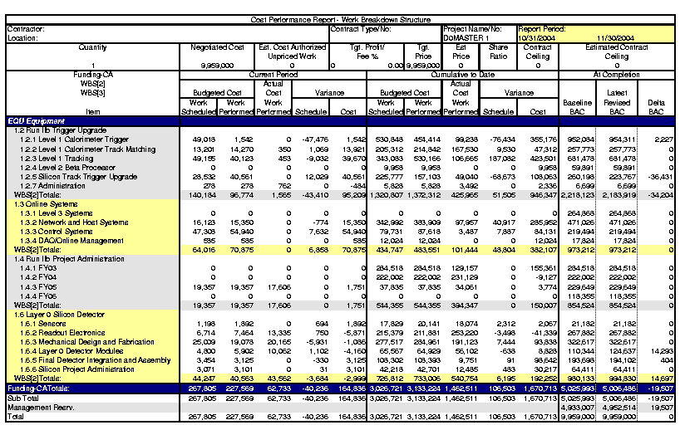

- Obligation Reports (as of 30 November 2004)

The DZero Obligation Reports can be found below. The first report shows total obligations without the cost of the original Run IIb silicon and related closeout costs. The second report shows all obligations.

